Experiment No: 6

Experiment Name: Windows Operating System Commands Execution

Aim
To execute and understand basic Windows network commands such as tracert, ping, ipconfig, and netstat for network analysis and troubleshooting.

Procedure

Open Command Prompt in Windows by pressing Windows + R, typing cmd, and pressing Enter.
- Execute the ping command:
- Execute the tracert command:
- Execute the ipconfig command
- Execute the netstat command:

Output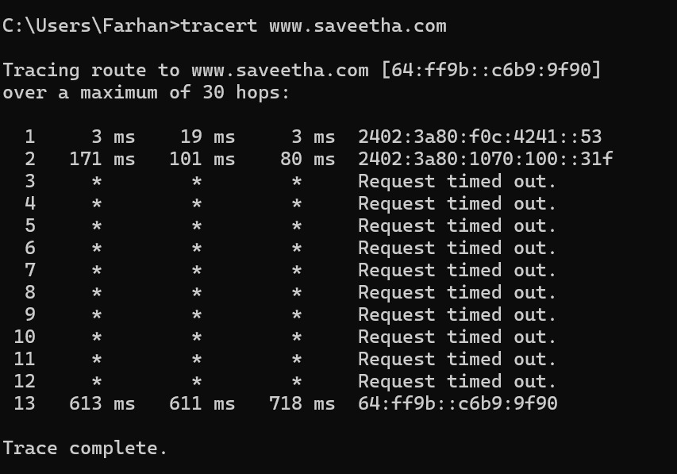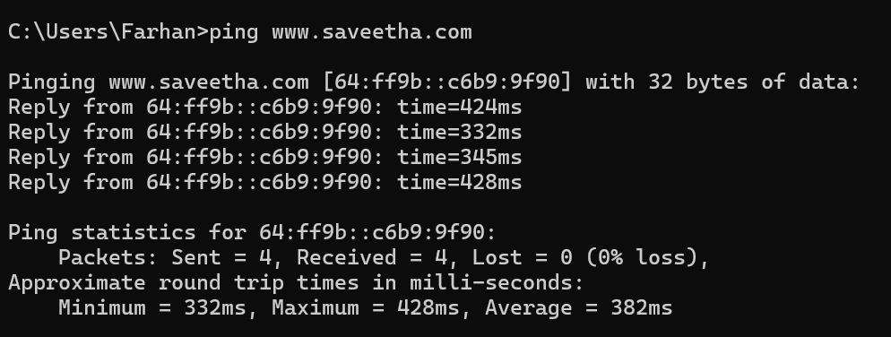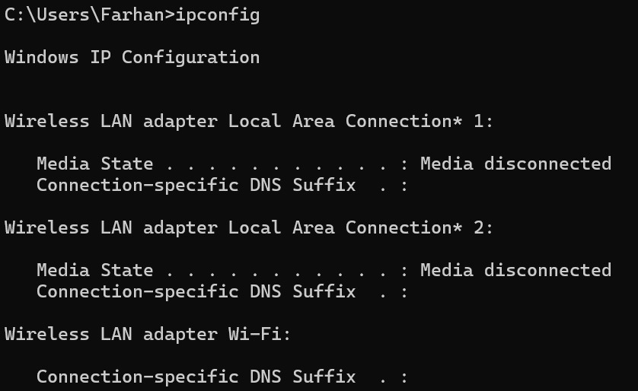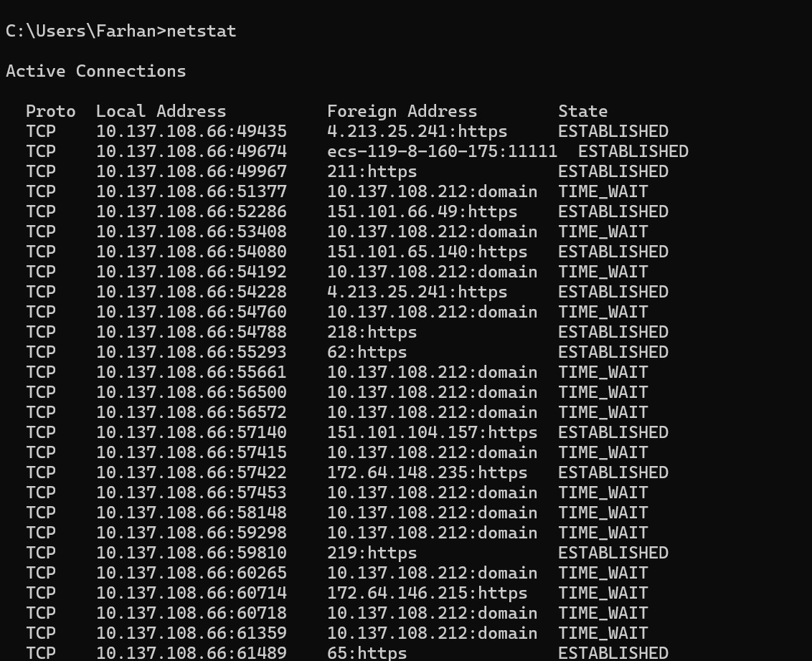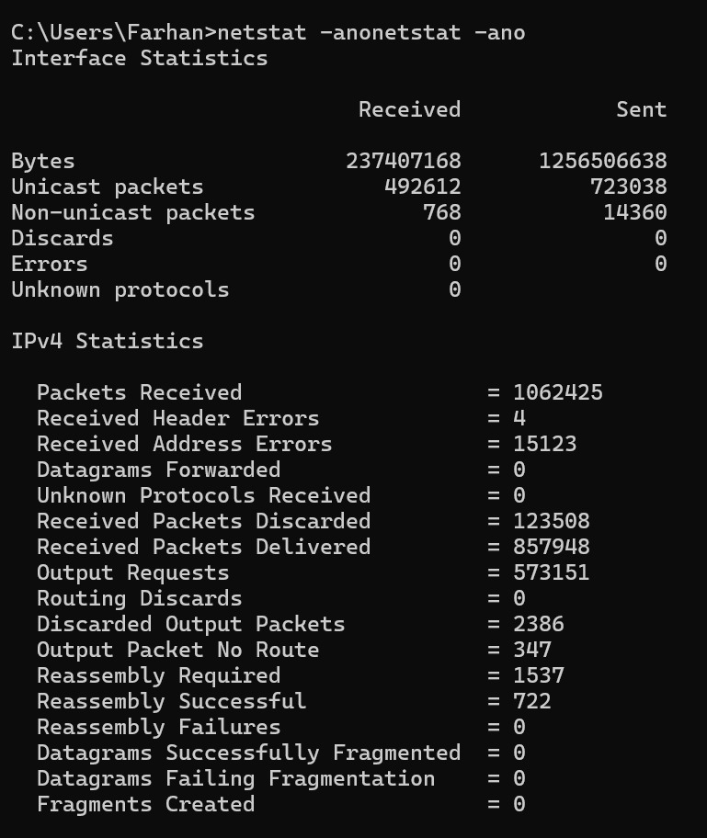

Result
Thus, the Windows network commands ping, tracert, ipconfig, and netstat were successfully executed, and the network connectivity, routing path, IP configuration, and active network connections were identified.

